Lab 06:
Question#01:
CODE:
#include <iostream>
using namespace std;

class Shape
{
protected:
int numberOfSides;
double area;

public:
Shape(int sides, double area = 0) : numberOfSides(sides), area(area)
{
}
int getNumberOfSides()
{
return numberOfSides;
}
int getArea()
{
return area;
}

void setNumberOfSides(int sides)
{
numberOfSides = sides;
}
void setArea(double a)
{
area = a;
}

virtual void generateArea() = 0; // Virtual Function so derived classes can override.
// pure virtual --> Shape is abstract.
};

class Rectangle : public Shape
{
protected:
double length, width;

public:
Rectangle(double l, double w) : Shape(4), length(l), width(w)
{
}

void generateArea() override
{
area = length * width;
}

double getLenght()
{
return length;
}
double getWidth()
{
return width;
}
};

class Circle : public Shape
{
private:
double radius;

public:
Circle(double r) : Shape(0), radius(r)
{
}
void generateArea() override
{
area = 3.142 * radius * radius;
}
};

class Triangle : public Shape
{
private:
double height, base;

public:
Triangle(double h, double b) : Shape(3), height(h), base(b)
{
}
void generateArea() override
{
area = (height * base) / 2;
}
};

class Square : public Rectangle
{
public:
Square(double side) : Rectangle(side, side)
{
}

void checkIfSquare()
{
if (length == width)
{
cout << "This is a square." << endl;
}
else
{
cout << "This is not a square." << endl;
}
}

void generateArea() override
{
area = length * width;
}
};

int main()
{
Rectangle rect(5, 3);
rect.generateArea();
cout << "Area of Rectangle: " << rect.getArea() << endl;

Circle circ(4);
circ.generateArea();
cout << "Area of Circle: " << circ.getArea() << endl;

Triangle tri(4, 6);
tri.generateArea();
cout << "Area of Triangle: " << tri.getArea() << endl;

Square sq(4);

sq.generateArea();
cout << "Area of Square: " << sq.getArea() << endl;
sq.checkIfSquare();
return 0;
}

Output:
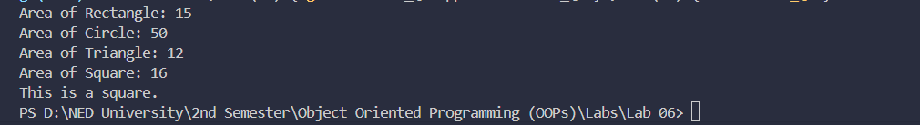

Question#02:
CODE:
#include <iostream>
using namespace std;

class Calculator{
private:
double num1, num2, num3;

public:
Calculator(int a, int b, int c) : num1(a), num2(b), num3(c){

}
double add(double a, double b){
return a + b;
}

double add(double a, double b, double c){
return a + b + c;
}
double subtract(double a, double b){
return a - b;
}

double subtract(double a, double b, double c){
return a - b - c;
}

double multiply(double a, double b){
return a * b;
}
double multiply(double a, double b, double c){
return a * b * c;
}
double divide(double a, double b){
if(b == 0){
cout << "Division not possible" << endl; return 0;
}
return a / b;
}
double divide(double a, double b, double c){
if(b == 0 || c == 0){
cout << "Division not possible" << endl; return 0;
}
return a / b / c;
}

};

int main() {
Calculator calc(0, 0, 0);
double n1, n2, n3;
cout << "===========This is a basic arithmic calculator=========" << endl;
cout << "Enter 3 Numbers: " ;
cin >> n1 >> n2 >> n3;

cout << "Addition (2 Numbers): " << calc.add(n1, n2) << endl;
cout << "Addition (3 Numbers): " << calc.add(n1, n2, n3) << endl;
cout << "Subtraction (2 Numbers): " << calc.subtract(n1, n2) << endl;
cout << "Subtraction (3 Numbers): " << calc.subtract(n1, n2, n3) << endl;
cout << "Multiplicattion (2 Numbers): " << calc.multiply(n1, n2) << endl;
cout << "Multiplicattion (3 Numbers): " << calc.multiply(n1, n2, n3) << endl;
cout << "Division (2 Numbers): " << calc.divide(n1, n2) << endl;
cout << "Division (3 Numbers): " << calc.divide(n1, n2, n3) << endl;
return 0;
}

Output:
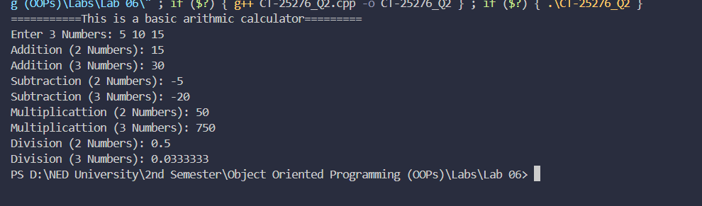
Question#03:
CODE:
#include <iostream>
#include <cmath> // for sqrt() in magnitude
using namespace std;

class Vector {
private:
double x, y;

public:
// ─────────────────────────────────────────
// Constructor
// ─────────────────────────────────────────
Vector(double x = 0, double y = 0) : x(x), y(y) {}

// ─────────────────────────────────────────
// Operator Overloading
// ─────────────────────────────────────────

// + operator: adds two Vectors
Vector operator+(const Vector& other) {
return Vector(x + other.x, y + other.y);
}

// - operator: subtracts two Vectors
Vector operator-(const Vector& other) {
return Vector(x - other.x, y - other.y);
}

// * operator: multiplies Vector by a scalar
Vector operator*(double scalar) {
return Vector(x * scalar, y * scalar);
}

// / operator: divides Vector by a scalar
Vector operator/(double scalar) {
if (scalar == 0) {
cout << "Error: Division by zero!" << endl;
return Vector(0, 0);
}
return Vector(x / scalar, y / scalar);
}

// ─────────────────────────────────────────
// Magnitude: √(x² + y²)
// ─────────────────────────────────────────
double magnitude() {
return sqrt(x * x + y * y);
}

// ─────────────────────────────────────────
// Display the vector nicely
// ─────────────────────────────────────────
void display(const string& label = "") {
if (!label.empty()) cout << label << ": ";
cout << "(" << x << ", " << y << ")" << endl;
}
};

int main() {
Vector v1(4, 3);
Vector v2(1, 2);

v1.display("v1");
v2.display("v2");

cout << "\n--- Operator Demonstrations ---" << endl;

// Addition
Vector sum = v1 + v2;
sum.display("v1 + v2");

// Subtraction
Vector diff = v1 - v2;
diff.display("v1 - v2");

// Multiplication by scalar
Vector scaled = v1 * 3;
scaled.display("v1 * 3");

// Division by scalar
Vector divided = v1 / 2;
divided.display("v1 / 2");

// Magnitude
cout << "\nMagnitude of v1: " << v1.magnitude() << endl; // √(16+9) = 5
cout << "Magnitude of v2: " << v2.magnitude() << endl; // √(1+4) = 2.236

return 0;
}

Output:
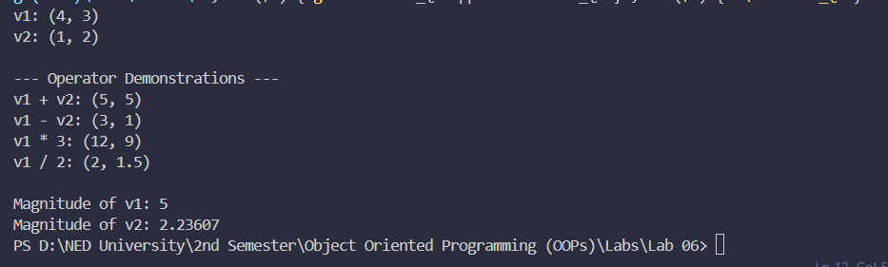
Question#03:
CODE:
#include <iostream>
using namespace std;
// Base class Person
class Person {
protected:
string name;
string occupation;

public:
Person(string occ) {
occupation = occ;
}

virtual void Draw() {
cout << "A person can draw in many ways" << endl;
}
};

// Derived class Artist
class Artist : public Person {
public:
Artist() : Person("artist") {

}

void Draw() override {
cout << "An artist can draw with a paint brush" << endl;
}
};

// Derived class Gunman
class Gunman : public Person {
public:
Gunman() : Person("gunman") {

}

void Draw() override {
cout << "A gunman draws a gun to shoot" << endl;
}
};

int main() {
// Array of Person pointers of size 3 (Person, Artist, Gunman)
Person* arr[3];

// Dynamically create objects
arr[0] = new Person("person");
arr[1] = new Artist();
arr[2] = new Gunman();

for (int i = 0; i < 3; i++) {
arr[i]->Draw();
}

delete arr[0];
delete arr[1];
delete arr[2];

return 0;
}

Output:
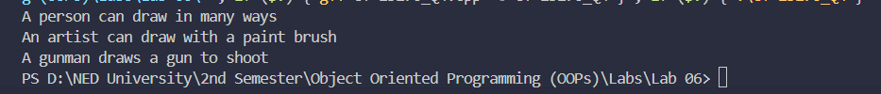

Made By: Faarid Amir Shaikh CT- 25276

